

**Popular Culture**

Have a look at the old toys in the POP Gallery, can you figure out which toys these photographs are showing?

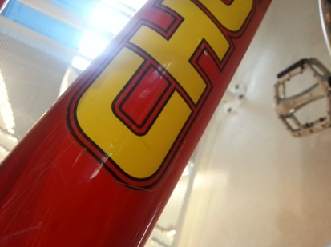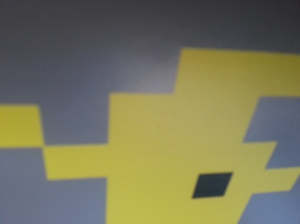

Can you draw a picture of your favourite toy from the Gallery in this box?

This is my favourite toy because …………………………………………………………………………………………………………

