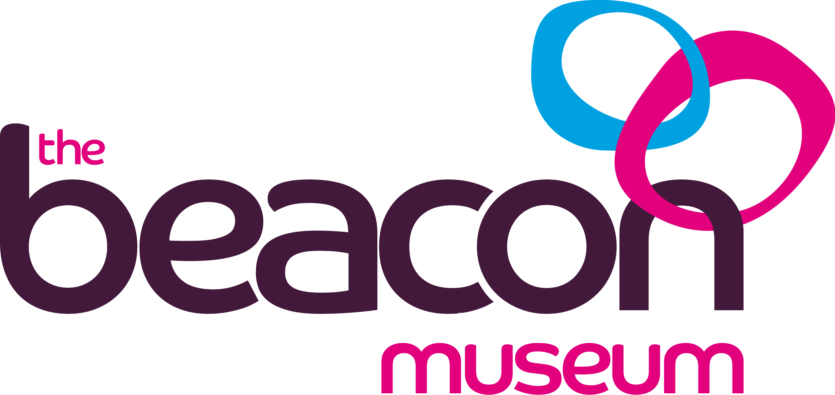

Health & Safety Information
For
Schools and Groups
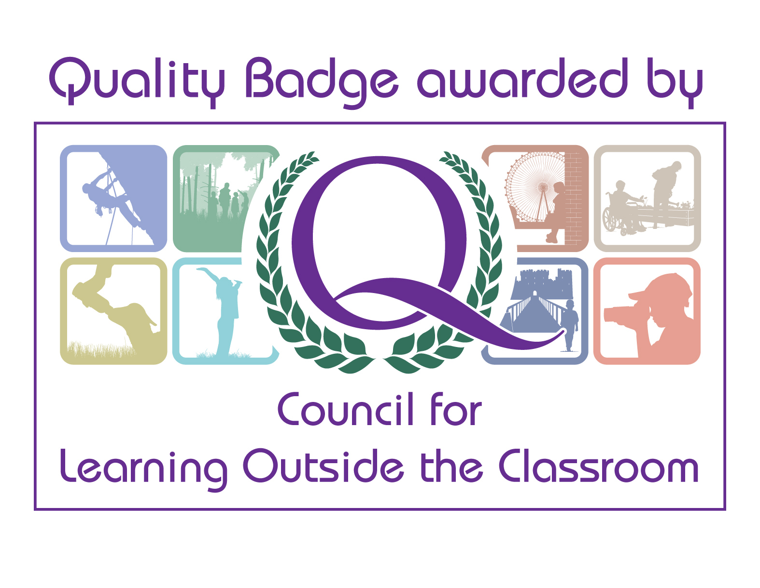



Health & Safety within The Beacon Museum

The Beacon is a museum provided as a public service by Copeland Borough Council.

The Council recognises and accepts its responsibilities for providing, so far as is reasonably practicable, a place to work and visit where conditions will ensure the health, safety and welfare of all employees and visitors. All members of staff working at The Beacon Museum, take their health & safety responsibilities seriously.

This commitment to health & safety helps to create a working environment, which has adequate facilities and arrangements to ensure that visitors will be safe and not subject to any unnecessary risks.

To help us achieve this safe environment, it is necessary to have certain rules and regulations which your group must follow.

Please read the following information, which includes the most recent Risk Assessment for the Activity Room and some basic codes of conduct while using the facilities.

A Health & Safety Declaration Form is provided with this booklet. Please fill it in and bring it with you on your visit.

Unfacilitated Visits

If you are running your own session in The Beacon Museum, either in the Activity Room or within the Galleries, you must first visit The Beacon Museum for a familiarisation visit. We offer a free preliminary visit for teachers planning any self-led or Museum led visit. We recommend you take advantage of this in order to familiarise yourself with the layout of the museum.

Please contact a member of the Learning Team to organise your free visit and to discuss your requirements for the day.

Please complete and sign the attached Health & Safety Declaration Form and hand it in at Reception on arrival.

Please ensure that any adults accompanying the visit have also read these instructions and that you are happy that they will comply with our Health & Safety requirements.

Beacon Museum staff-led sessions

If you have booked in for an activity session or guided tour, we still require your Health & Safety Declaration to be handed in at Reception on arrival. You will be met by a member of Beacon Learning Team and taken to the Activity Room for your session.

Please remember that during the session, the lead teacher remains responsible for all the children on the visit and should stay with them at all times.

Adult: Child Ratio

The Beacon Museum recommends that you have a minimum of 1 adult to 10 children for any visit.
For sessions in the Activity Room you must have 1 adult to 8 children if the children are aged 8 years or over and a ratio of 1 adult to 6 children for children under 8 years old.

The Beacon Museum reserves the right to refuse admission to groups not complying with these ratios.

Emergency Evacuation

Please ensure that you have a list of all the children on your visit with you at all times. If this is your regular class list, please ensure that any absentees are clearly marked and that any extras are added on. We may need to use this list in the event of an emergency evacuation.

If the fire alarm sounds while you are in The Beacon Museum galleries, make your way with your group to the nearest exit. A Visitor Host will help you if you are unsure. All the exits are clearly marked.

If the fire alarm sounds whilst you are in the Activity Room, please follow the member of the learning team out of the fire exit. If there is no member of the Beacon Museum team present, make your way out of the building using the designated fire exit, safely cross the road and wait opposite the Bistro entrance.
If any member of your party is missing, please report this to a member of museum staff.

Should an evacuation take place that is not fire related, please follow the instructions given by museum staff.

Accident Reporting

Please ensure that all accidents and incidents are reported to the Duty Manager. Relevant forms will be completed with your input.

Food and Drink

Please note that food and drink are not permitted within the Galleries at The Beacon Museum. You may eat lunch in the Activity Room if you have pre-booked this room.

Refreshments may also be bought and eaten in the café.

Sessions in the Activity Room

- All coats, and bags where possible, to be hung up on the hanging rail.
- Money should be kept with you at all times. Unfortunately, The Beacon Museum cannot accept responsibility for valuables left unattended.
- Talk to the children before they leave school and when they arrive at the museum about safe procedures. Make sure they understand what they can and can’t do.
- Children must follow instructions given by member of Beacon staff when handling objects.
  - Children must not pass objects from one table to the other.
  - Objects should be held low over the table while they are being examined.
  - Some objects are made of glass and extra care should be taken. Some objects have sharp points.

Medical Emergencies

If a child is taken ill while you are in The Beacon Museum, please use a phone (available on all landings and in the Activity Room) to contact Reception. Dial 14. They will send a first aider, telephone for an ambulance or do whatever is required. First Aid box is kept in the Beacon Museum Shop Store next to Reception.

Visiting the Galleries

- All children visiting the Galleries must be supervised at all times.
- Children should be allowed to enjoy themselves during their visit, but please don’t allow them to run around.
- Please make children aware that there will be other visitors in the Museum.
- The mannequins in the galleries on the 3rd floor can be quite frightening for young children. Please warn the children in advance.
- There are often special instructions for visitors to the Harbour Gallery. These will be visible in the gallery and will change according to the exhibition on show. They might ask you not to touch anything, or to touch everything! Please make sure that the children follow these instructions.
- The Beacon is built on 5 floors and the exit is on the 1st Floor.
- Toilets can be found on the 3rd Floor (gents and 1 adapted toilet), 2nd Floor (ladies), 1st Floor (unisex and 1 adapted) and Ground Floor Education Suite (2 unisex and 1 adapted).

Health & Safety Declaration

Please bring this form with you when you make your visit and hand it in at Reception.

Declaration

I have read the Health & Safety instructions for groups visiting The Beacon. I agree to comply with these instructions. I will ensure that every adult accompanying my party of children has read these health & safety notes before arriving at the Museum and I am satisfied they will comply with the instructions.

Name:
School / Nursery / Pre School:

Purpose of visit:
Date of visit:

Signature:

Date:

Occasionally, and only with the agreement and in the presence of a teachers or leader, we take photographs of educational activities and events for use both in internal reports and external publicity. If you would rather we did not take photographs at all, please tick this box.

