Quantum Leap is a club at The Beacon Museum, Whitehaven, for 7 – 13 year olds, who are interested in history, heritage, science and exploring. The year’s programme will be based upon the John Muir Discovery Awards, that centre on discovering, exploring, conserving and sharing a local wild historic habitat. Our chosen place for 2018 is Whitehaven Harbour and the surrounding area.
The club’s focus for 2018 is to deliver a more varied experience with science and conservation through outdoor activities.

We usually meet on the second Saturday of the month between 10am – 12 midday
In Quantum Leap your child will be able to….
- Take part in real historical and scientific research.
- Achieve a nationally accredited award.
- Narrate their own discovery story for a future exhibition.
- Handle living sea creatures, as well as historical artefacts and images.
- Have fun, meet new friends and explore.

Our set price for 2018 is £30 for 12 sessions

Please Complete the form overleaf and return digitally or to the Beacon Museum in paper form to reserve your space(s) for Quantum Leap 2018. Spaces are limited and will be dealt on a first come first served basis.
Telephone 01946 592302
Email: quantum.leap@copeland.gov.uk

To Sign Up to become a Quantum Leap Explorer, please complete the form below;

Name ………………………………………………………………………………... Date of birth……………..………………………………….

Contact details of parent or guardian;
Name …………………………………………………………………………….…….Mobile Number………………………………………………
Name …………………………………………………………………………….…….Mobile Number………………………………………………
E-mail address……………………………………………………………………………………………………………………………………………….
You will receive monthly updates on the Quantum Leap with reminders about the month session topic. All future sessions might have to be amended where necessary. An e-mail update will be sent out to notify you prior to the event date.
Please e-mail the completed form to quantum.leap@copeland.gov.uk or post the form back to The Beacon Museum, West Strand, Whitehaven, CA28 7LY. We will contact you via phone to confirm your booking and take your payment.
Parent/ Guardian Volunteer Form
PARENT/GUARDIANS

PLEASE FILL OUT ENTIRELY

Parent Name…………………………………………………………………………………………………………...

Preferred Email address (please print) ……………………………………………………………………

Phone number…………………………………………………………………………………………………………

Preferred method of contact: _______email ______phone call

We are pleased that your child would like to be a part of Quantum leap for 2018. We value the ongoing support of adults in helping with this club. Please indicate below what months you intend to be present at the club with your child, and if you are happy to act as volunteer for the session. Please note volunteers will receive an emailed session briefing prior to the day, and are requested to arrive 15 minutes early on the day to receive a briefing from session leaders.

Jan Present [ ] Volunteer [ ] July Present [ ] Volunteer [ ]
Feb Present [ ] Volunteer [ ] Aug Present [ ] Volunteer [ ]
Mar Present [ ] Volunteer [ ] Sept Present [ ] Volunteer [ ]
April Present [ ] Volunteer [ ] Oct Present [ ] Volunteer [ ]
May Present [ ] Volunteer [ ] Nov Present [ ] Volunteer [ ]
June Present [ ] Volunteer [ ] Dec Present [ ] Volunteer [ ]

Diary Dates for Quantum Leap 2018

All sessions are based at the Beacon Museum unless otherwise stated. A minimum attendance of 9 sessions is required to obtain your John Muir Award accreditation.

Explanatory Codes for Session requirements

G - Working in smaller accompanied groups
V - Parent volunteers especially required
O - Outdoor activity- please dress accordingly
E - Excursion- travel arrangements tbc.
Wheelchair friendly session

Saturday 13th January
10am-12 midday
Introducing the John Muir Award programme. Setting the scene for the year’s programme and getting to know one another. (O)(V)

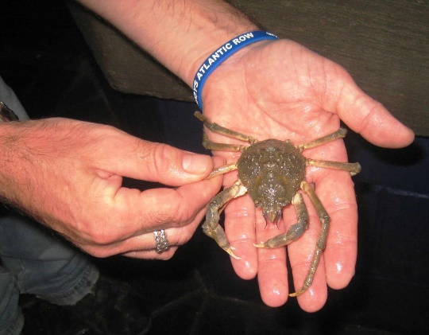
Saturday 10th February
10am-12 midday
Rock pool exploration with the Maryport Aquarium. Delve into the deep and find out from the experts about the creatures living in and around the Solway.

Saturday 10th March
10am-12 midday
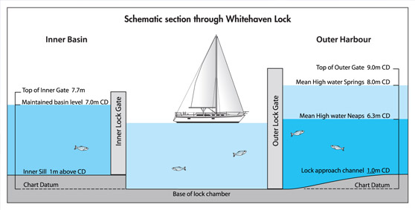
Taming the tides. A visit to Whitehaven Marina to see how the lock gates were built and how they work to keep the marina afloat. (O)(V)
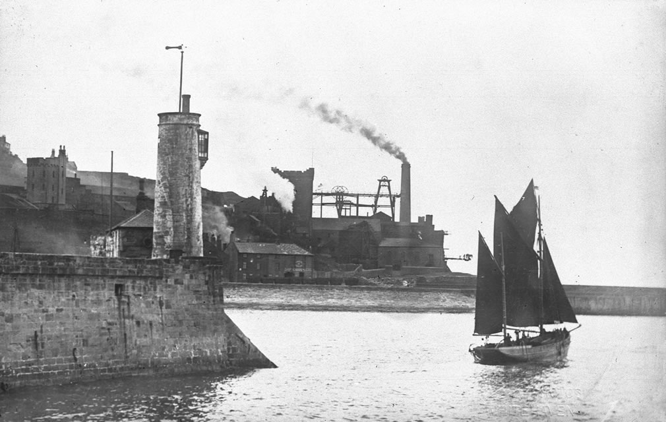
Saturday 14th April
10am-12 midday
Whitehaven harbour then and now. Research and share images of the harbour from past times and map out the changes. Listen to stories and think creatively about staging your own group exhibition! (G)

Saturday 12th May
10am-12 midday
Test your theories. As researchers for the day, survey the wildlife in the harbour and interview people on what they see and do in the area. (G)(V)

Saturday 9th June
10am-12 midday
Beach Detectives: work to help clean up a local beach and analyse catalogue some of the items that you find there. (O)(V)

Saturday 14th July
10am-12 midday
Art attack. Get creative in creating your own piece of recycling inspired art- with help from art workshop leaders.

Saturday 11th August
10am-12 midday
Brick Dinos and Lego League. Test out your mechanical minds using some of the coolest new Lego© gadgets, and see some of the creations in action from First Lego League.
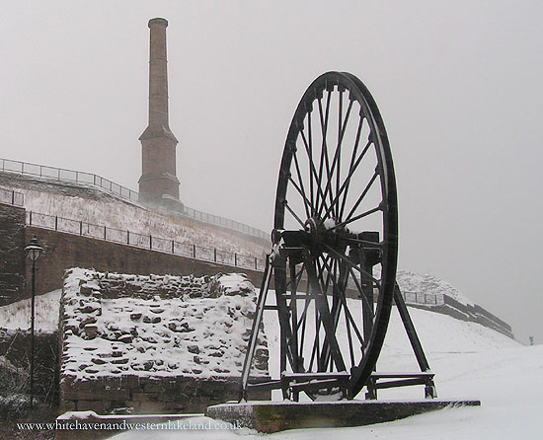
Saturday 8th September
10am-12 midday
Whitehaven of old. Explore the Candlestick, Haig Pit and old Marchon sites as you learn about the industries of times gone by, and how they have impacted the natural habitats around them. Part of
Heritage Opens Days for 2018. (O)(V)

Saturday 13th October
10am-12 midday
The Big Draw 2018. Develop your exhibition. Art, creative writing and multimedia workshop where you can present the story of Whitehaven harbour in your own way.

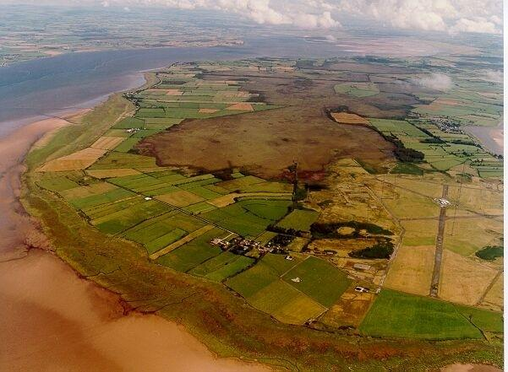
Saturday 10th November
10 am-3pm
Solway Adventure. Expand your knowledge of our coast with a visit to the Solway wetlands. Find out what creatures use this habitat, and how humans have also used it.
Part of the Kids in Museums
Festival. (O)(E)(V)

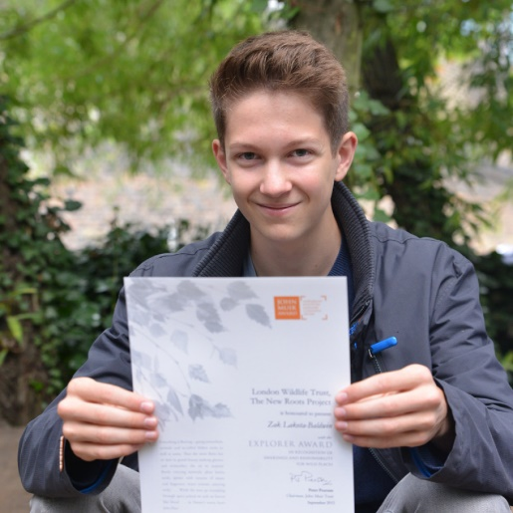
Saturday 8th December
11am-1pm
End of year celebration with party and awards presentation with special guests. (V)

The Beacon Museum reserves the right to amend this schedule. Additional activities may be included. Any changes will be notified at least 1 month in advance.

The Beacon Museum, West Strand, Whitehaven, CA28 7LY Tel: 01946 592302 www.thebeacon-whitehaven.co.uk

Quantum Leap Official T shirt and Hoodie.
As members of the Quantum leap Club, we would love the children to have a feeling of ownership when participating in the club during 2018. We will therefore give children the option to order a branded t shirt and/ or hoodie with the club’s livery included. (Example below is a rough artists impression- you can see the real thing in January before ordering)
This is by no means compulsory and won’t affect your child’s membership of the club if they choose not to order one.
Aiming to keep your costs down, the garments will be offered at cost price to club members.
Size Guide (for both t-shirt and hoodie)
Ages 7-8/ 9-10 / 11-12 / 13 / 14 /15
Prices
T shirts are £9
Hoodies are £13

Order Form

I wish to order
Quantum Leap T-shirt [ ]
Quantum Leap Fleece [ ]
Size (Please circle)
Ages 7-8 9-10 11-12 13 14 15

Name of Child: ………………………………………………………………………………….
Payable with yearly fees at time of reservation/ or at museum reception during the year.

